How to Back Up Your Files Using Cobian Backup

Notes:
Please read notes overleaf to help understand the backup procedure

- Close any open programs, including email
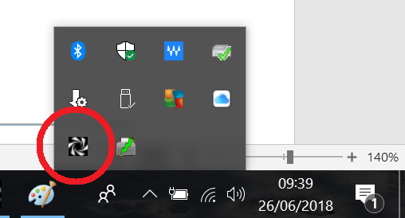
- Plug in your USB memory stick or hard drive
- Find Cobian’s black and white “swirly” icon in the bottom right corner of you screen
- Right-click the black and white icon
- Left-click ‘Open’
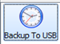
- Cobian Backup opens on screen
- Left-click the relevant task in the left column
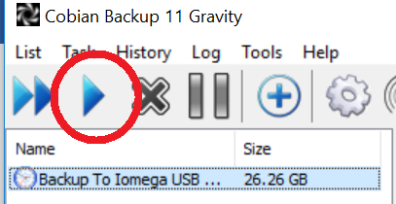
- Left-click the single triangle icon
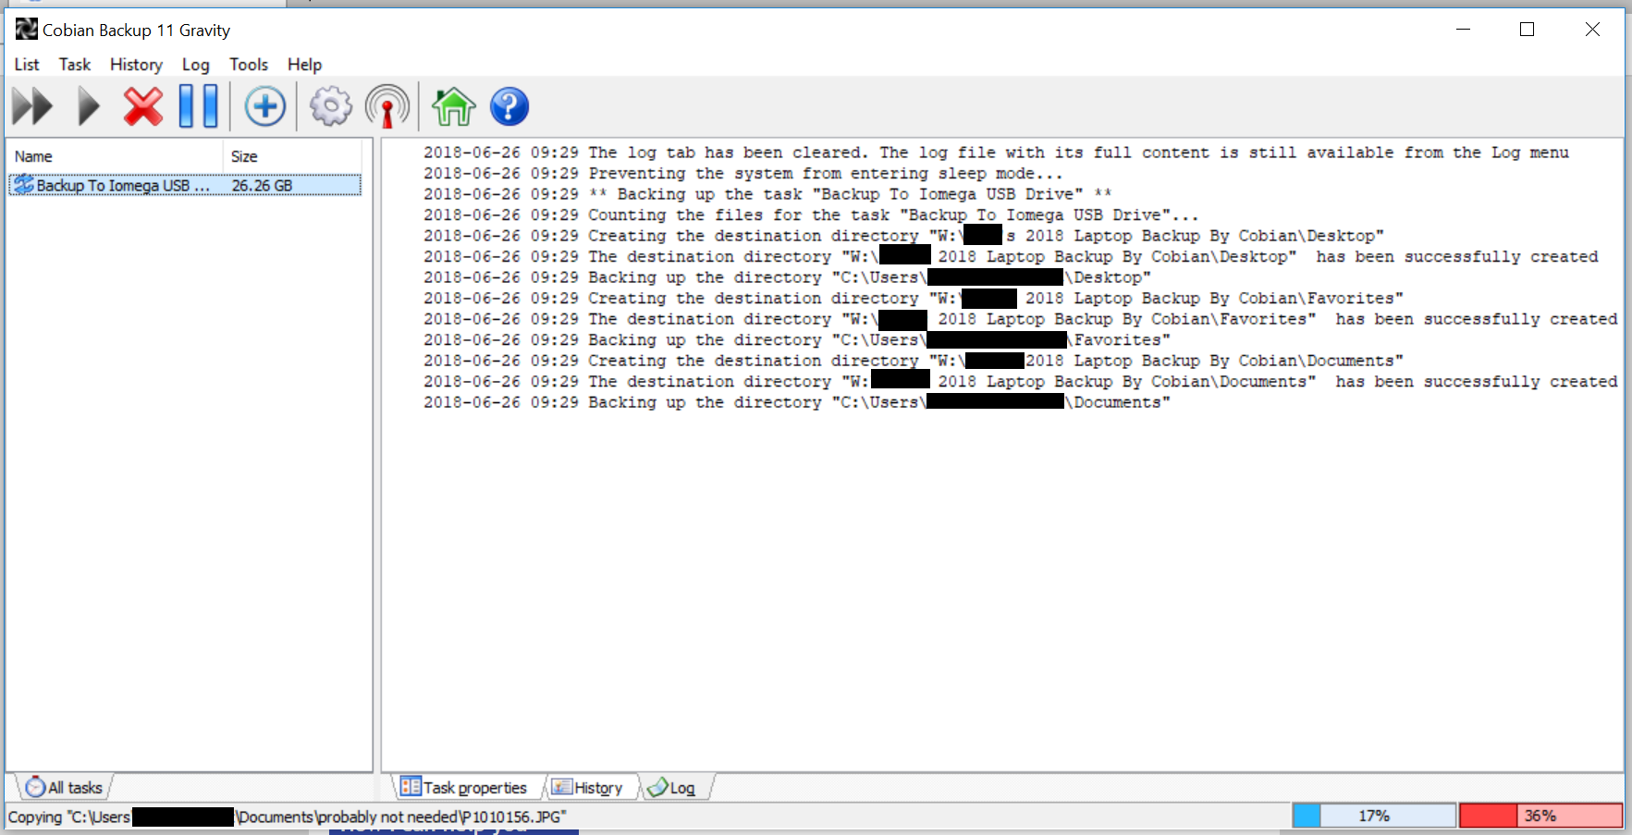
- Wait for the backup to run.
It will look similar to this,
with the red bar at the bottom
indicating progress
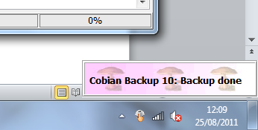
- When the backup is complete, you will be told at the bottom of the screen, and may hear a sound
- Close Cobian
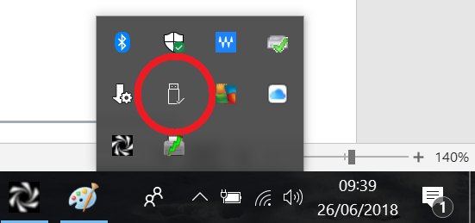
- Before unplugging your USB memory stick (or hard drive), in the bottom-right corner, left click the Safely Remove Hardware icon
- Then left-click the name of your memory stick (or hard drive)
- Once the computer says it is safe to do so, you may unplug your memory stick
- Remember to put the stick (or hard drive) somewhere safe afterwards

Cobian backup copies the contents of the following folders to your USB hard drive or memory stick:
- Documents
- Outlook (emails, contacts, calendar, tasks)
- Outlook Express
- Pictures
- Music
- Videos
- Desktop (icons and any files on main screen)
- Internet Explorer Favourites
- Firefox Bookmarks
- Windows Contacts

Important: Cobian only backs up the folders it has been told about. These can be reviewed and adjusted in the Cobian program by double clicking the task’s icon. Subfolders of those mentioned are included.
Look out for red text: Red text at the end of the backup could be telling you the backup did not work. Read the red text and if you are concerned, call me.

